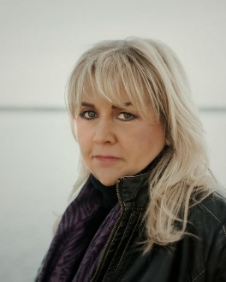
About the Author
Ellen Marie Wiseman

SHORT BIO:

Ellen Marie Wiseman is the New York Times bestselling author of the highly acclaimed historical fiction novels The Orphan Collector, What She Left Behind, The Plum Tree, Coal River, The Life She Was Given, and her forthcoming release, The Lost Girls of Willowbrook. Born and raised in Three Mile Bay, a tiny hamlet in Northern New York, she’s a first-generation German American who discovered her love of reading and writing while attending first grade in one of the last one-room schoolhouses in New York State. Since then, her novels have been published worldwide, translated into eighteen languages, and named to “Best Of” lists by Reading Group Choices, Good Housekeeping, Goodreads, The Historical Novel Society, Great Group Reads, and more. A mother of two, Ellen lives on the shores of Lake Ontario with her husband and dogs. Visit her online at EllenMarieWiseman.com

EXTENDED BIO:

Ellen Marie Wiseman is a New York Times bestselling author whose highly acclaimed historical fiction novels have been translated into eighteen languages and published worldwide. Born and raised in Three Mile Bay, a tiny hamlet in Northern New York, she’s a first-generation German American who discovered her love of reading and writing while attending first grade in one of the last one-room schoolhouses in New York State.

Her writing career began in 2013 with the publication of her debut novel, The Plum Tree. Inspired by her mother’s stories about growing up in Germany during the chaos of WWII, it was praised by Jewish Books World as “a story of intrigue, terror, and love from a perspective not often seen in Holocaust novels.” Her second novel, What She Left Behind, was named a Best Books of Summer by The Huffington Post and went on to sell more than half a million copies in the United States alone. This success continued with Coal River in 2015 and The Life She Was Given in 2017, which was a Great Group Reads selection of the Women’s National Book Association, a Goodreads Best Books of the Month, and a selection of theSkimm Reads. Her fifth novel, The Orphan Collector, was an instant New York Times bestseller, a Target Book Club Pick, Good Housekeeping Best Historical Fiction Books, and the Reading Group Choices Top 10 Readers’ Favorite Books of the Year. Her forthcoming novel, The Lost Girls of Willowbrook, will be published by Kensington Books in August 2022.

Ellen Marie Wiseman is frequently praised for the compassion, authenticity and depth with which she explores real historical injustices, events and places rarely seen in novels. Whether evoking the immigrant experience of the 1918 Spanish Flu pandemic (The Orphan Collector), life in a Depression-era traveling circus (The Life She Was Given), the impact of WWII on the lives of average Germans (The Plum Tree), insane asylum patients in the 1930’s (What She Left Behind), the resilience of children exposed to atrocious conditions in an early 1900’s coal town (Coal River), or the treatment of children with disabilities as recently as the 1970s (The Lost Girls of Willowbrook), Wiseman delivers stories that demand to be read, talked about and enjoyed.

A mother of two, Ellen lives on the shores of Lake Ontario with her husband and a spoiled Shih-tzu named Izzy. Visit her online at EllenMarieWiseman.com

Ellen Marie Wiseman’s Acclaimed Novels

- The Lost Girls of Willowbrook
(Trade Paperback Original / August 30, 2022 / ISBN: 978-1-4967-1588-3)
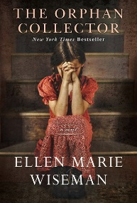
In her most powerful novel to date, New York Times bestselling author Ellen Marie Wiseman masterfully viscerally evokes the real-life Willowbrook State School, the infamous Staten Island, New York, mental institution that shocked a nation when exposed in the 1970s. Girl, Interrupted meets One Flew Over the Cuckoo's Nest in this gripping narrative of social injustice, survival, and a young woman determined to find her sister.

- The Orphan Collector
(Trade Paperback Original / August 2020 / 978-1-4967-1587-6)
With vivid writing and immediately absorbing characters, Ellen Marie Wiseman weaves a moving, harrowing, but ultimately exultant novel set in Philadelphia during the 1918 Spanish Flu pandemic.

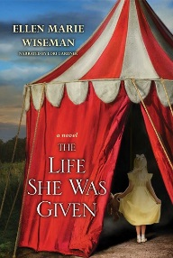
- The Life She Was Given
(Trade Paperback Original / August 2017 / ISBN: 978-1-61773-449-6)
Ellen Marie Wiseman’s international bestseller merges past and present, as the discovery of an abandoned journal inside a shuttered state asylum compels a young woman to piece together its original owner’s fate – with shocking and unexpected results. Illuminating and provocative, What She Left Behind is a haunting story about the nature of love, loyalty, and the lengths we will go to protect those who need us most.

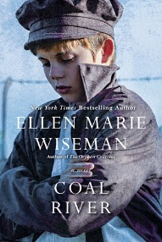
- Coal River
(Trade Paperback Original / December 2015 / ISBN: 978-1-4967-3001-5)
Stunningly repackaged from the acclaimed author of What She Left Behind and The Orphan Collector, the story of a young woman orphaned and sent to live with abusive relatives in a Pennsylvania coal town in the early 20th century. There she encounters broken young boys working under atrocious conditions in the mines, and her concern for them opens a window to the suffering of miners and their families, as well as the key to healing her past…
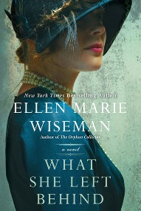
- What She Left Behind
(Trade Paperback Original / January 2014 / ISBN: 978-1-4967-3003-9)
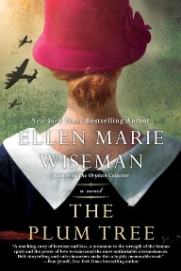
Ellen Marie Wiseman’s international bestseller merges past and present, as the discovery of an abandoned journal inside a shuttered state asylum compels a young woman to piece together its original owner’s fate – with shocking and unexpected results. Illuminating and provocative, What She Left Behind is a haunting story about the nature of love, loyalty, and the lengths we will go to protect those who need us most.

- The Plum Tree
(Trade Paperback Original / January 2013 / ISBN: 978-1-4967-3002-2)
Praised by Jewish Book World as “a beautifully written story of intrigue, terror, and love from a perspective not often seen in Holocaust novels," Ellen Marie Wiseman's highly acclaimed debut novel follows a young German woman through the chaos of World War II and its aftermath as she struggles to survive poverty, Allied bombs, and agents of the Third Reich while trying to save the Jewish man who is the love of her life.

